Chapter 7 :11, 12, 16 (Use Dijkstra and show your work), 17, 20, 21

**Q11**

**a**

|  |  |
| --- | --- |
| **Nodes(N)** | **Links** |
| **2** | **1** |
| **3** | **2** |
| **4** | **3** |
| **5** | **4** |
| **6** | **5** |

As seen from the table, in a network, N-1 links are required to connect N nodes.

**b**

Mesh network. In which there would be multiple nodes along the same path due to which the disconnection of one node will not affect the other nodes as much. Also using a store and forward, packet switching method to enable the network to be more reliable.

**Q12**

Increase reliability of the network. As if there is only the exact set of nodes required, if one of them are to fail the entire network would not function going forward. The extra nodes allow to reduce the effect the disconnection of a couple of nodes would have on the overall functionality. It would also help to reduce collisions in the network.

**Q16** a,b

**

**Q17**

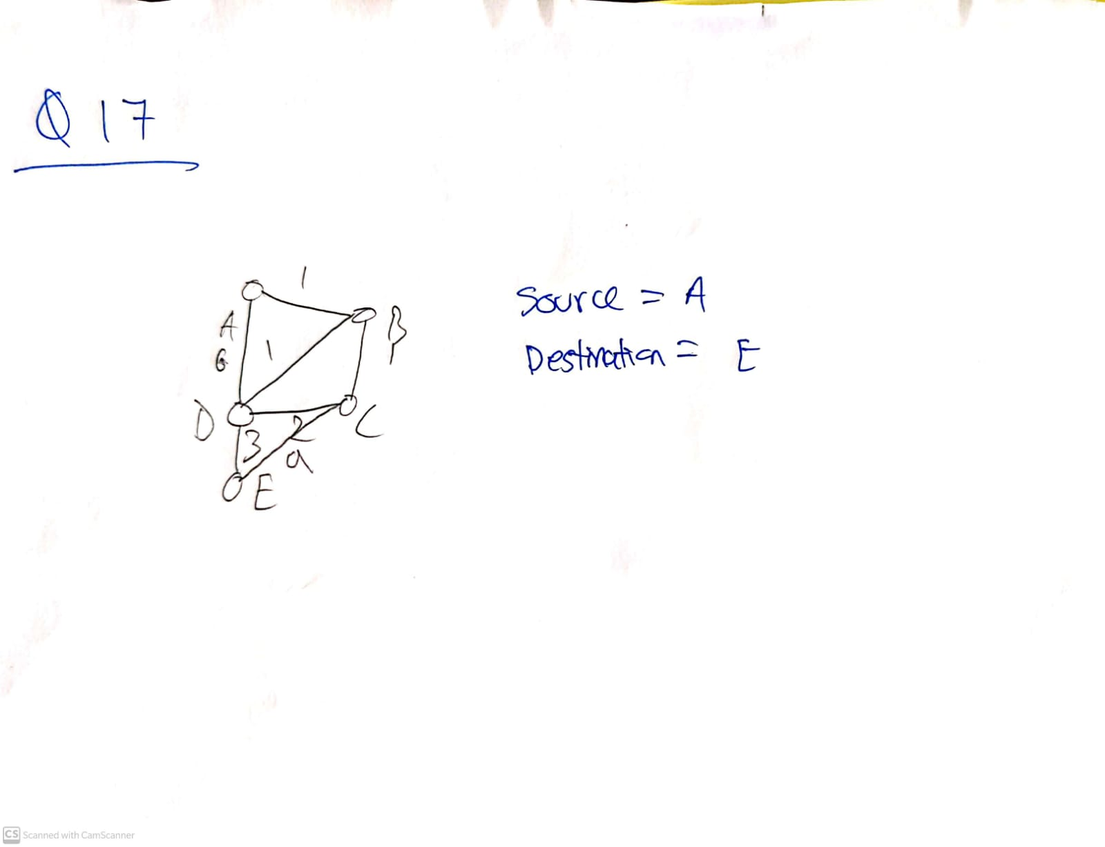

**Q20**

Breaking down into smaller packets reduces the error in each message. As each message is now responsible for a small chunk hence reducing the liability it has making the overall structure more reliable. Breaking down can also help with additional error handling as if a error is detected, only the specific section is needed to be resent rather than the entire message. Sending information as packets can also be cheaper as each node would need to process a smaller amount of information at each time leading to a lower required cost on hardware and infrastructure.

**Q21**

The internet began as a means to enable social interactions through a network which was initiated by JCR Licklider of MIT in 1962. He visioned a globally connected system of computers through which anyone could access information and programs. The current model of The Internet was based off of this approach as mentioned by Licklider. He was the first head of computer research at DARPA and pioneered its growth going forward.

In 1961, Leonard Kleinrock at MIT published a paper on packet switching theory. He convinced other fellow scientists to use the packet switching method for communications over the regular circuit method. They began working on a a way to allow computers to talk and communicate with each other. They began by connected two computer’s in the US over a low speed dial up telephone line and created the first wide area computer network. They realised that connected computers could work together by running programs and retrieving data as required but also realised the circuit in the telephone line was inappropriate for the level of communication required. We also learned in class the benefits of using a packet switching approach which would be a more efficient and reliable communication method.

In 1966, Kleinrock’s partner Lawrence G Roberts moved to DARPA to develop the computer network through his plan of ARPANET. There was also parallel work at RAND on packet switching networks for securing voice communications and the previous mentioned work at MIT. Over the years with research, ARPANET was finalised and the first ever node was selected to be at UCLA. Over the next few years the first message through ARPANET was sent from UCLA to Stanford. As computers were added, a complete host to host protocol and relevant network software was being setup. These protocols are the backbone of the communications we perform today. In 1972 a basic email message send and receive software was written by Ray Tomlinson and as he added more functionalities to the software their popularity grew and began to be widely used.

It is pretty interesting to realise every single thing we do on the internet had to be broken down and prepared using small steps. Such as even sending and receiving messages would require a sophisticated and complex system. Something which we may take for granted today.